**Примеры заданий промежуточной аттестации по английскому языку. 8Д класс.**

**Задание 1. Подпишите, какая погода изображена на каждой картинке.**

|  |  |
| --- | --- |
| 1. https://fs.znanio.ru/d5af0e/c5/fd/170ed3f1d1ea7fdd0971abaceb7fba0ba0.jpg | 2. https://i.pinimg.com/736x/bd/0c/5a/bd0c5a28a49c2c16b0acbc440bbcb68b--sunny-days.jpg |
| 3. https://gazeta-chi.ru/uploads/entries/6%D0%A2%D1%83%D1%87%D0%BA%D0%B0%20%D0%B8%20%D1%81%D0%BD%D0%B5%D0%B6%D0%B8%D0%BD%D0%BA%D0%B8.jpg | 4. https://sun9-69.userapi.com/impg/x-FC0XckrdtiO5sFSbpgUDJPg9W7CVj8_wY-2w/B9v4BgJFtRo.jpg?size=575x424&quality=95&sign=9a94aceda0870cf9b60f2596fa280d3c&c_uniq_tag=To5SvV27bYUjcTgLvcWRanQMMh79CvquvhXO4BzGWWo&type=album |

**Задание 2. Сравните два предмета или животных, используя слова из скобок**

Пример: 0. (big) – The dog is bigger than the cat (Собака больше, чем кот)

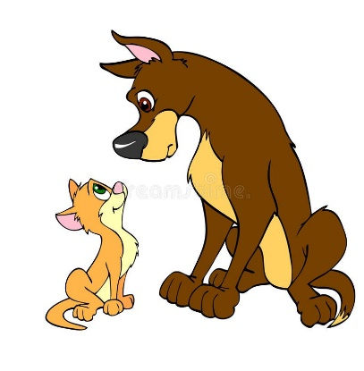

dog

cat

|  |  |
| --- | --- |
| 1. (old)  https://thumbs.dreamstime.com/b/%D0%B2%D0%BD%D1%83%D1%87%D0%BA%D0%B0-%D0%B0%D0%B2%D0%B0%D1%8F-%D1%86%D0%B2%D0%B5%D1%82%D0%BA%D0%B8-%D0%BA-%D0%B1%D0%B0%D0%B1%D1%83%D1%88%D0%BA%D0%B5-76454819.jpg  granddaughter  granny | 2. (beautiful)  https://www.clipartmax.com/png/full/3-33070_flower-in-bloom-clip-art-best-drawing-of-flowers.pnghttps://clipart-library.com/images/yikrL966T.png  the flower  the tree |

**Задание 3. Напиши каждый из этих глаголов в прошедшем времени:**

1. play - _________

2. be - __________ / ______________

3. work - _______________

4. go - _______________

5. do - _______________

6. travel - ______________

**Задание 4. Выбери правильную временную форму в каждом предложении и обведи ее.**

1. Last week my family and I (travel / traveled) to the USA.

2. Next month my little brother (went / will go to school).

3. The weather (was / is) cold and snowy yesterday.

4. Last month I (went / go) to the zoo with my friends.

5. Tomorrow I (worked / will work) in the garden with my granny.

**Задание 5. Прочитай текст о прошлых выходных Тессы (Tessa). Отметь, если утверждения после текста верные обведи (True), если неверные (False).**

Last weekend was very pleasant for Tessa. On Saturday morning she was at home but on Saturday afternoon she was in the park with her friends. It wasn’t windy or rainy. The day was warm and sunny and Tessa was happy. In the evening Tessa was in the swimming pool.

On Sunday Tessa’s brother and Tessa were in their grandmother’s cottage. Their parents were not with them, they were at work. It was foggy and windy on Sunday and the children were in the cottage together with their grandmother and her little dog. The dog was not happy. It likes to run but it can’t run in the cottage.

It is Monday evening now. The children aren’t walking in the park, they are at home. It is rainy and cold in the street. The sky is cloudy. Tessa doesn’t like nasty weather but her father does. He is putting on his boots and coat. Нe wants to go to the shop and buy some food.

1) On Saturday afternoon Tessa was at home. True / False

2) Tessa’s brother was in the park on Sunday. True / False

3) The weather wasn’t fine on Sunday. True / False

4) The children are in the cinema now. True / False

5) The sun is shining in the blue sky now. True / False